 | ISSN: XXXX-XXXX | 2026/1
 | SYNEX JOURNAL OF MOBILITY & BUSINESS RESEARCH | 2026/1
 | www.synexjournal.org | 2026/1
Title (Times New Roman 14pt Bold)
Name Surname^{1*}, Name Surname² and Name Surname³ (Times New Roman 10pt).
^{1*}………………University, ……………………… Department. (..........@............edu.tr). ORCID: XXXX-XXXX-XXXX-XXXX
² ………………University, ………………………. Department. (..........@............edu.tr). ORCID: XXXX-XXXX-XXXX-XXXX
³ ………………University, ………………………. Department. (..........@............edu.tr). ORCID: XXXX-XXXX-XXXX-XXXX

Article Info (Do not try to change) |  | Abstract
Received: xx.xx.2026  Revised: xx.xx.2026  Accepted: xx.xx.2026  Published: xx.xx.2026 |  | The abstract must be prepared in English for each article and should be between 150–250 words. In this section, the author(s) should explain the purpose of the study, research methods, design used, how data was obtained and analyzed, and briefly mention the results obtained.
Keywords:
Keywords 1, Keywords 2, Keywords 3
Keywords 4, Keywords 5, Keywords 6.
Jel Code:
XXXX
Corresponding Author:
Name Surname
Research or Review Article
(Do not try to change)
https://doi.org/10.xxxxx/xxxxxx
(Do not try to change)

Introduction (Times New Roman 11pt Bold)
In this section, the subject of the study and the research problem should be clearly presented, and the importance of the study should be justified by stating its purpose. Explanations based on the existing literature should be made in this part, and citations should be given in accordance with APA 7 rules.

Conceptual Framework / Theory
This section summarizes previous research conducted in the studied field and the results obtained. Readers have the opportunity to compare studies conducted by different researchers on the same subject in terms of research method, findings, and results.

Method
The research design should be explained in detail, and the data collection techniques used, sampling, and analysis process should be clearly described. The statistical methods or qualitative analysis techniques applied should be detailed to a level that ensures replicability of the study. In-text texts within tables should be written in Times New Roman, 10 pt.

Findings and Method
The necessary tables and figures regarding the findings obtained should be presented clearly and comprehensibly. The titles of the tables should be placed at the top, and the titles of the figures should be placed at the bottom. Both should be numbered and titled in accordance with APA 7 standards.

Table 1. This is the example of table formatting (Times New Roman 10 pt)
Date | Airline / Flight No. | Aircraft Type | Location / Country | Fatalities
29 Dec 2024 | Jeju Air Flight 2216 | Boeing 737-800 | Muan Intl., South Korea | 179
25 Dec 2024 | Azerbaijan Airlines Flight J2-8243 | Embraer ERJ-190AR | Near Aktau, Kazakhstan | 38
9 Aug 2024 | Voepass Linhas Aéreas Flight 2283 | ATR 72-500 | Vinhedo, São Paulo, Brazil | 62
24 Jul 2025 | Angara Airlines Flight 2311 | Antonov An-24RV | Tynda, Amur Oblast, Russia | 48
Reference: synexjournal, (2021)
Figure 1. This is the example of figure (Times New Roman 10 pt)
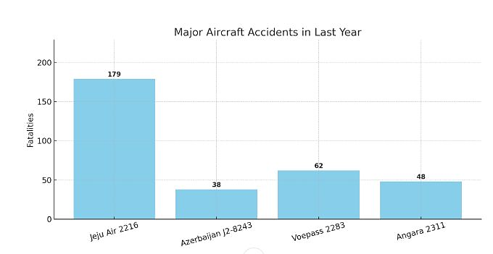
Reference: synexjournal, (2021)

Conclusion and Recommendations
By summarizing the findings, a conclusion section containing theoretical and practical contributions should be created, and suggestions for future studies should be provided.

Acknowledgements
The authors would like to express their sincere appreciation to all individuals and institutions who contributed to the development of this study. Special thanks are extended to [insert name or institution, if applicable] for their valuable guidance and constructive feedback. This research did not receive any specific grant from funding agencies in the public, commercial, or not-for-profit sectors.

Author Contributions
Author 1: Conceptualization, Methodology, Formal Analysis, Writing – Original Draft, Supervision, Project Administration.
Author 2: Data Curation, Formal Analysis, Visualization, Writing – Review & Editing.
Author 3: Investigation, Validation, Resources, Writing – Review & Editing.

(The author contribution statements are defined according to the CRediT taxonomy as follows: Conceptualization; Methodology; Software; Validation; Formal analysis; Investigation; Resources; Data curation; Writing – Original draft; Writing – Review & Editing; Visualization; Supervision; Project administration; Funding acquisition.)

Declaration of Interest
The authors declare that they have no known competing financial interests or personal relationships that could have appeared to influence the work reported in this paper.
If the authors do have any financial interests or personal relationships that could be considered as potential competing interests, they should be clearly stated here

Ethical approval
Not applicable. / Yes xxxxx.xxxx.xxx

Reference
Aydın, U. (2025). A novel CINFUS-SWARA-TOPSIS methodology for evaluating horizontal alliances between hotels and airlines. Journal of Multidisciplinary Academic Tourism, 10(2), 133–148.

Alkan, N., Aydın, U., Menekşe, A., & Kahraman, C. (2025). Comparison of the performances of artificial intelligence bots using continuous intuitionistic fuzzy evaluation based on distance from average solution method. Engineering Applications of Artificial Intelligence, 161, 112033. https://doi.org/10.xxxxxx

Kaya Aydin, G., & Aydin, U. (2022). Is there any convergence in the CO₂ emission efficiency of airlines? Environmental Science and Pollution Research, 29(12), 17811–17820. https://doi.org/10.xxxxxx

Aydın, U., Karadayi, M. A., & Ülengin, F. (2020). How efficient airways act as role models and in what dimensions? A superefficiency DEA model enhanced by social network analysis. Journal of Air Transport Management, 82, 101725. https://doi.org/10.xxxxxx

All works cited within the study must be included in the references section. Moreover, no publication not cited in the study should be included in the references section. The references section is extremely important in terms of scientific ethics, and authors must select their references with great care. This is a requirement that falls under the responsibility of the authors.

